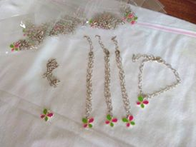
Instructions for Making a Charm Bracelet.

Materials:

Chain -Chain may be purchased from Emporiums or Spotlight. Sold by the metre.
(Do not buy fine chain as it is not strong enough for the bracelet)

Parrot clasps sometimes called Oyster clasps -available from Spotlight

5 cm jump rings -one for the end and as many more as are needed for charms.

Charms – IFG butterfly charms available from Seeit; additional charms available from Spotlight in packets of 10.

Pliers – Keep your eyes open for this type of jewellery pliers as they have the rounded points suitable for making loops and the cutter for snipping wires. Spotlight, Mitre 10 or Emporiums.

Method:

1. Chain needs to be cut into lengths of between 16 -20cms lengths. (As you buy this chain in metre lengths you may have some left over – the bits can be joined together to give you enough for another bracelet).

2. Prise one of the chain links apart at one end and put on a clasp closing the link of chain up again. Join the bracelet together using the clasp

3. Using the 5cm jump rings, using pliers open it to attach the charm and then attach this to the bracelet, closing the ring.

4. Other charms are added as the girls earn them.

